**MESD Documentation LMS-91-Bulk-import**

**Purpose**

To allow for users to enter large amounts of information into the LMS quickly.

**Background**

The MESD LMS will need bulk import ability to support input of user information as well as course information in an automated way from a data source.

**Upload Users**

Navigate to Site Administration -> Users -> Upload users

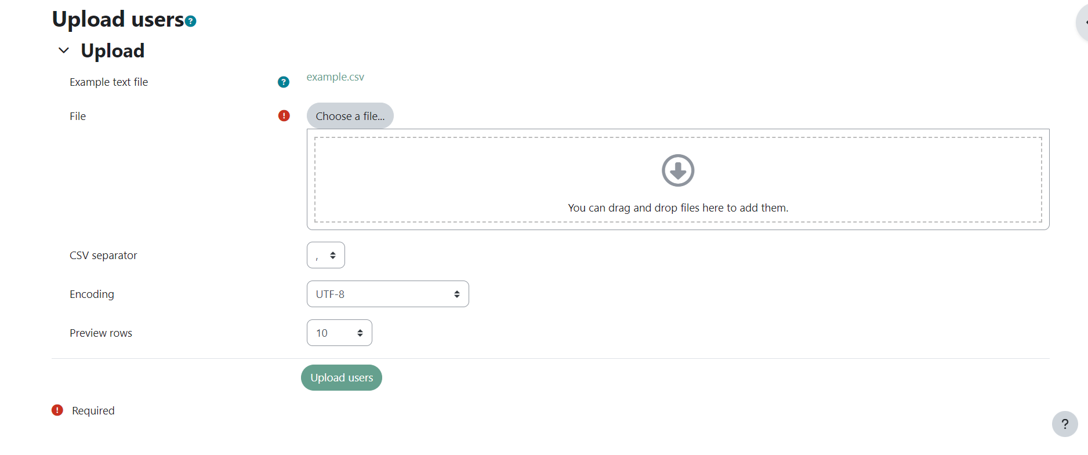

Upload a csv file from sheet 1 of the template user import template.xlsx

**NB - Only upload one type of users at a time i.e Students Only then Educators then next batch of users**

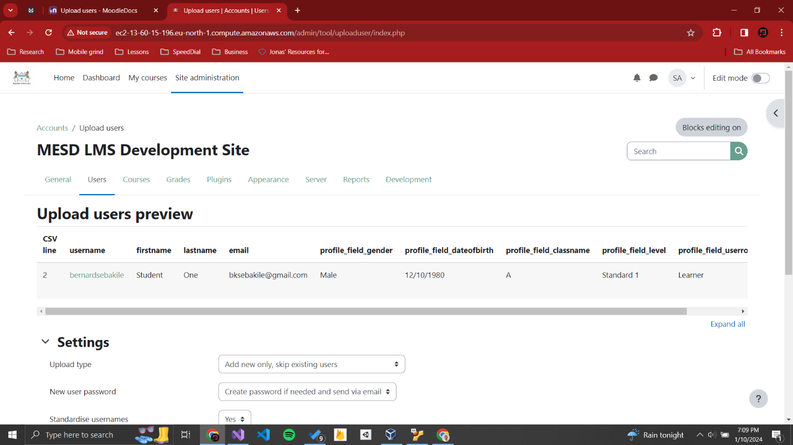

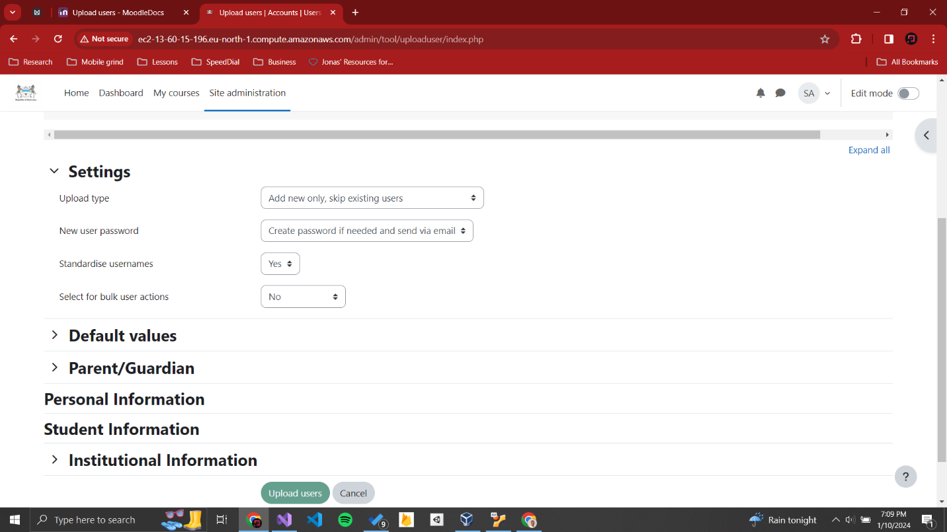

Finally click the Upload users button.

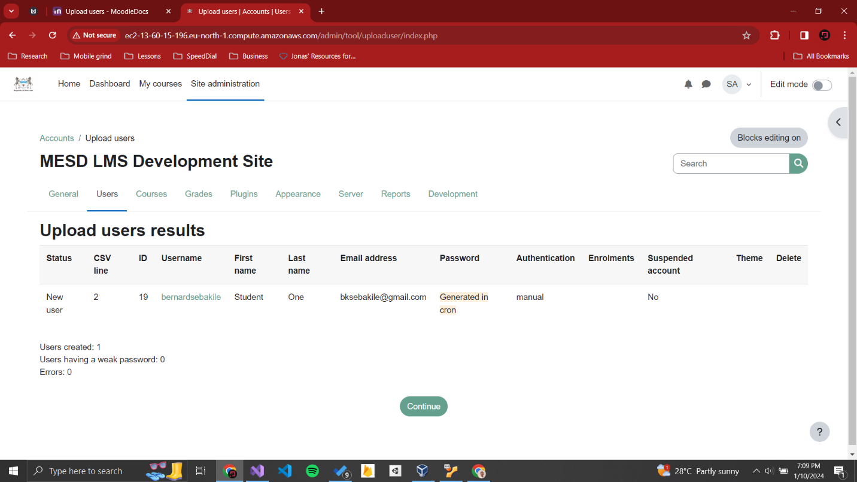

**Upload Courses**

In addition to creating new courses, the upload courses functionality may also be used to update or delete courses, or import content from another course. For information on using this functionality to create course templates, see [Adding a new course](https://docs.moodle.org/403/en/Adding_a_new_course).

To upload one or more courses

1. Go to *Administration > Site administration > Courses > Upload courses*
2. Either drag and drop the CSV file or click the 'Choose a file' button and select the file in the file picker
3. Select appropriate import options carefully, then click the preview button.

|  |  |  |
| --- | --- | --- |
| Upload courses admin screen |  | Courses successfully uploaded |

Note: It is also possible to use the command-line tool *admin/tool/uploadcourse/cli/uploadcourse.php*.

When using the web interface, use the *Preview* option to see if any errors were detected in the previewed rows. If you proceed with the upload and there were something wrong detected with a course, it will be ignored.

You can use the template courseuploadtemplate.csv